Ophidian 2350 Rulebook
“Get with the Flow”

Contents

Story by Loren L. Coleman "To Fight Another Day"
Welcome to Ophidian

Game Overview 1.0
Victory Conditions 1.1
Golden Rule 1.2
Flow 1.3
Getting Started 1.4
Card Types 2.0
Gladiator Cards 2.1
Strategy Cards 2.2
Arena Layout 2.3
Credit Points 2.4
Using the Flow 2.5
Passing 2.6
Starting the Fight 3.0
Setup 3.1
Begin Play 3.2
Playing a Card 3.3
Setting Cards 3.4
Movement 3.5
Attacks 3.6
Intercepting and Protecting 3.7
Using XDMG 3.8
Wounds and Destroying 3.9
Raging 3.10
Gaining Crowd Favor 3.11
Reinforcements 3.12
The Breather 4.0
Continue the Match 4.1
Victory Conditions 4.2
Example Game 5.0
Disciplines and Species 6.0
Multi Player 7.0
Advanced Rules 8.0
Glossary 9.0

To Fight Another Day
By Loren L. Coleman

Hear the crowds. Their stomping feet. The applause of clashing metal and clapping flesh.
Hear half a million shouting voices rolling through New Moon arena, like God’s Own Thunder.
David Dangers dropped to the arena’s brightmetal floor, rolling out from under Pago’s wild slash. The energy blade blurred overhead in a slash of blue-white lightning. It spit hot sparks of crackling energy that singed David’s muscular shoulders, his thick neck. The smell of burnt meat rose up behind hot ozone.
Coming up onto his knees, his back toward the alien, David spent a flicker of thought on his aural suppressors, muting the crowd’s savage clamor with nanotech filters until only his stage name pounded through in a lustful chant.
Freakshow…Freakshow… Other Gladiator names whispered through as well. Cray. Mannequin. Lillith. His partners for this match. Lillith fought her own private war against Prince of Gates on the far side of the arena; alien versus demon. Cray Phillips and Mannequin held the arena’s center, doubling up against Leetah and Hammerhands.
He would have to watch Cray, the man looked weak. But not now. His job was to stop the alien construct, Pago.
David Dangers loved his work.
Sensing Pago moving up from behind, David wrapped a blanket of green-tinged questing force around himself. It bought him time—seconds, perhaps—to strengthen his heartbeat and push more nanite-laced blood into his muscles. Fatigue dropped away like the robe he had shrugged off after entering the Ophidians’ arena. A few of his tattoos darkened as the neo-skin beneath them flushed a dark bronze. His aura thickened, strengthened—
—darkened as a violent red slash tore in toward his neck.
Anticipating the attack, David arched his back and pinned his own shoulders against the cold brightmetal of the arena floor. His gauntleted hands swept up, clapping together where his head had been, catching the blade of Pago’s energy weapon in the gauntlets’ admantite grip.
With adrenaline-pushed reflexes and the flexible spine of titanium-laced graphite provided only recently by the Ophidian Lords, David used leverage from Pago’s grip on the weapon to yank the alien off-balance and at the same time thrust back with his own hips. His legs swung around and behind, locking into unbreakable rams which speared into the cyborged Ulescue’s midriff.
David felt something crack underfoot. Maybe armor. Maybe Pago’s natural chitin carapace.
Nothing wrong with Pago’s battle instincts, though. Any Gladiator that pushed a bad position risked his life along with the match. The reconstructed alien gave up the energy blade, throwing David forward on the strength of his own muscles. A cyborg arm raked half a dozen metal razors down David’s back as he went, drawing bloody trails all the way down to the right thigh.
But implanted under David’s skin was a weave of monomolecular threads coated in biometal. KEV armor. The unbreakable strands dulled Pago’s razor-tipped fingers but did not break them off. Now David had the energy weapon; a short halberd-type device with titanium pole and a curving blade of sapphire energy. Dancing up to his feet, favoring his right side only slightly, he adjusted his grip on the polearm and locked admantite fingers around the shaft. Raising it overhead in victory, the multitudes above rained accolades over him that nearly overloaded his protective filters.
Pago wasn’t finished, though. From the end of both articulated arms sprang new weapons. A rotating blade, and laser. The Ulescue’s skullcase gleamed with an energy charge similar to the arena’s brightmetal floor, and drug-shot eyes burned red from burst blood vessels. If the cyborged alien cared that it had lost the crowd’s favor, it did not show it. All that mattered was the win.
All that really mattered, in the end, was living to fight another day.
Well David ‘Freakshow’ Dangers was a survivor too. And a veteran Gladiator. And as he leapt forward, the energy blade spinning in a blur of lightning and sparks around his head, he also knew that he’d take the adulations where he could get them.

Hear the crowd…

Welcome to Ophidian!

Ophidian is a collectible card game in which you control a team of Gladiators. Your enemies are other Gladiator teams… some of which may even contain some of the same Gladiators that make up your team! Curse those Bio-teknicians and their cloning!
You have up to four Gladiators in play at the start of the game. These are your main forces. You also have an Arsenal (deck). Your Arsenal contains the various resources to which your team may have access: Pumps, Quick-Hits, Minions, and other stuff.
You win when your team gains enough Victory Points (VP’s) or when you generate enough Cheer to incite a riot… in which the spectators rush the field and tear your opponent’s to pieces!
Don't be intimidated by the size of this rulebook; the game is very easy to learn and play. First, separate your cards by card type and compare them to the examples that follow. Then skim through the rules to get yourself familiar with them. Grab your cards, set up for a game, and duke it out! Refer to the rules as you need to.

What Is a Collectible Card Game?
With a collectible card game (CCG), you collect individual cards like, say, baseball cards. There are already over 240 cards in print for Ophidian, with another 120 or so releasing this fall. You either received the 2-player or 1-player starter. You can get additional cards by buying different starter decks and 11-card booster packs.
Unlike baseball cards, you can play games with these cards! As you collect more cards, you'll be able to build your own deck, customizing its focus and flavor, tailoring it to match your plan for victory.
Once you are happy with your deck, consider entering tournament play at a convention or local game store. Some tournaments will even have an effect on the storyline of the Ophidian Arenas. A continuing story will advance through each Ophidian CCG release (as well as on the website at www.ophidiangames.com), and you’ll have to stay tuned to see how it unfolds.

1.0 Game Overview
Each game of Ophidian represents one match in the Arena. Your job is to make a Gladiator team and build your deck around their skills. Each Gladiator has a broad range of skills, such as contaminating the arena with lethal contagions, opening dimensional portals, healing fatal wounds, creating destructive robots and more!
Each match is split into a series of Waves. Once a Wave starts, you must struggle to keep control because at any moment your opponent may steal your momentum.
As your Gladiators gain experience, their most effective Attacks are unleashed. Each Gladiator has different capabilities, so be sure to choose the team that is right for you.

1.1 Victory Conditions
First off, let’s talk about how to win! All of these rules will be explained later, but this will give you an idea of what you are shooting for:

• Annihilation Victory: Wipe ‘em out!
• Point Victory: Go after the big boys, and your opponents won’t be able to stop you!
• Crowd Riot Victory: This is a spectator sport… so win the crowd! If you excite them enough, they’ll riot, rushing the field and tearing your opponents limb from limb!

1.2 Golden Rule
If at any time a card contradicts the rules in the rulebook, the card is correct.

1.3 The Flow
An understanding of the Flow is very important in Ophidian.
Do you think a Gladiator would wait for his turn? Of course not! Combatants constantly attack, parry, dodge, and maneuver… anything to win!
The Gladiators who have the Flow make things happen. They are the ones in control, but that control is not fixed and at any moment an opponent may steal the Flow from them. Within the course of a single Wave, the Flow may change hands many times, fluidly switching from player to player.
Note: Rules governing the Flow in greater detail can be found on section 2.5.

1.4 Getting Started
To play Ophidian, you must have a 50-card Arsenal, up to 4 Gladiators with a total VP of 10, a six-sided die (d6), and some counters (coins, beads, tokens, etc). We have also provided you with two Counter Cards to easily track Credit Points (CP) and Cheer during the game.

2.0 Cards Types
In Ophidian, there are two main Card types: Gladiator Cards and Strategy Cards.
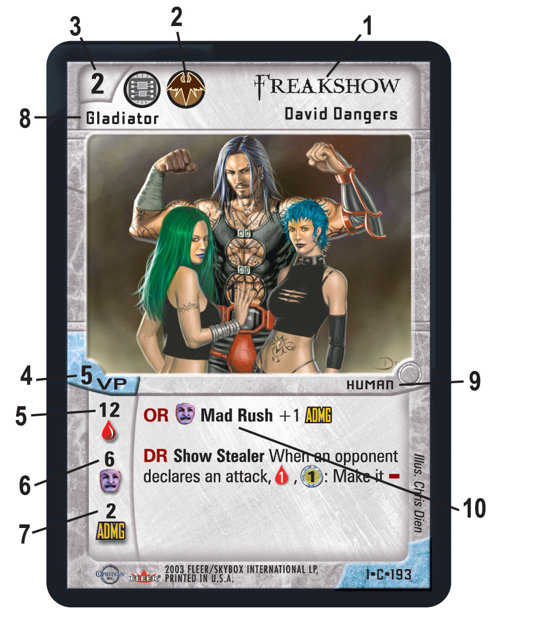
Figure 1 - Gladiator Card

2.1 Gladiator Cards (see Figure 1)
Gladiators are the main Characters controlled by a player. Each player chooses his or her Gladiator Cards during the game Setup and keeps them in their Gladiator Stack.

Anatomy of a Gladiator Card:
1. Name: Gladiator's Name.
2. Disciplines: Which discipline(s) the Gladiator can use.
3. Level: Determines how potent the Gladiator is and the highest-Level Strategy Cards he allows your team to play.
4. Victory Points: This number shows how much the Gladiator is worth when building a team and the amount of Victory Points he is worth when Destroyed.
5. Life: The amount of Wounds a Gladiator can sustain before he is Destroyed and removed from the game.
6. Raging Value: The amount of Wounds a Gladiator needs to start Raging.
7. ADMG: This is the amount of Attack Damage your Gladiator inflicts.
8. Card Type: This identifies the card as a Gladiator Card.
9. Keywords: Gladiators have keywords, including their species, which may be referred to by other cards.
10. Abilities: Unique abilities the specific Gladiator may use. Each of these abilities also has a Flow symbol that indicates a possible change in Flow when using the ability.
Back of Card: Gladiator cards are double-sided, each side with a different Level of that Gladiator.
Note: Reinforcement Gladiators have a standard Ophidian Back.

2.2 Strategy Cards (see Figure 2)
Strategy Cards work using the disciplines available to your Gladiators, giving them bonuses, minions, extra equipment, etc. They comprise the bulk of your Arsenal.
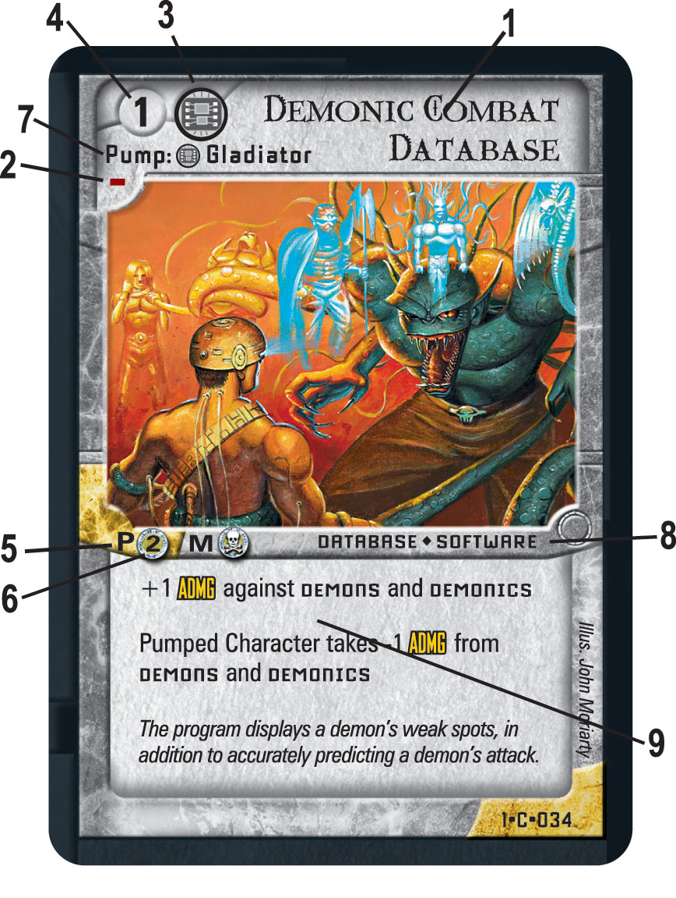
Figure 2 - Strategy Card

Anatomy of a Strategy Card
1. Card Name: Name of the card.
2. Play Flow Symbol: Describes whether you keep or lose the Flow when playing the card.
3. Discipline: A player may only play cards of a discipline he currently has on his team.
4. Level: At least one Gladiator on your team must be the same Level or greater than a card's Level in order to play that card. That Gladiator must also have the appropriate discipline(s).
5. Play Cost: How much CP is required to play the card.
6. Maintenance Cost: How much CP is required to maintain the card.
7. Type: Minion, Pump, Quick-Hit, or Zone.
8. Keywords: Some cards have keywords that may be referred to by other cards.
9. Abilities: Unique abilities the specific card may use. Each of these abilities also has a Flow symbol that indicates a possible change in Flow when using the ability.
Back of Card: All strategy cards have a standard Ophidian Back.

There are four types of strategy cards: Minions, Pumps, Quick-Hits, and Zones.

Minion: Minions are the technicians, lackeys and general support that will help your Gladiators survive and thrive in the arena. Minions are Characters like Gladiators, having life totals and are capable of many actions such as Attacking explained later. Minions enter the game in the Support Field.

Pump: Pump cards modify other cards on the table. When you play a Pump Strategy Card, you must choose a target and place the card underneath it. Pumps may be battle-gear for your Gladiators, gross diseases played on the enemy team, or just about anything else. If the Pumped target is Scrapped (discarded), the Pump must be Scrapped as well. You can have multiple Pumps of any type on the same Gladiator.

Quick-Hit: Quick-Hit Strategy Cards are exactly that. They represent instantaneous strategies. They give you a short-term benefit or immediate effect, but are Scrapped immediately after use.

Zone: A Zone card changes the Arena itself. It might represent a cloud of gas, a series of spikes on the floor or any number of other circumstances. Each time a Zone card enters play all face-up Zone cards are flipped face-down and all face-down Zone cards are flipped face-up. Only face-up Zone cards affect the game. Zone cards do not occupy any position on the Field, and are instead played beside your deck. You can only have four Zone cards in the Arena at any one time. When you bring a new Zone into play past the four-Zone limit, you must scrap one of your other face-up or face-down Zones in the Arena.

2.3 The Arena Layout
In the Ophidian CCG, the area used to play is known as the Arena. Each player's section of the arena contains four stacks of cards and two Fields.
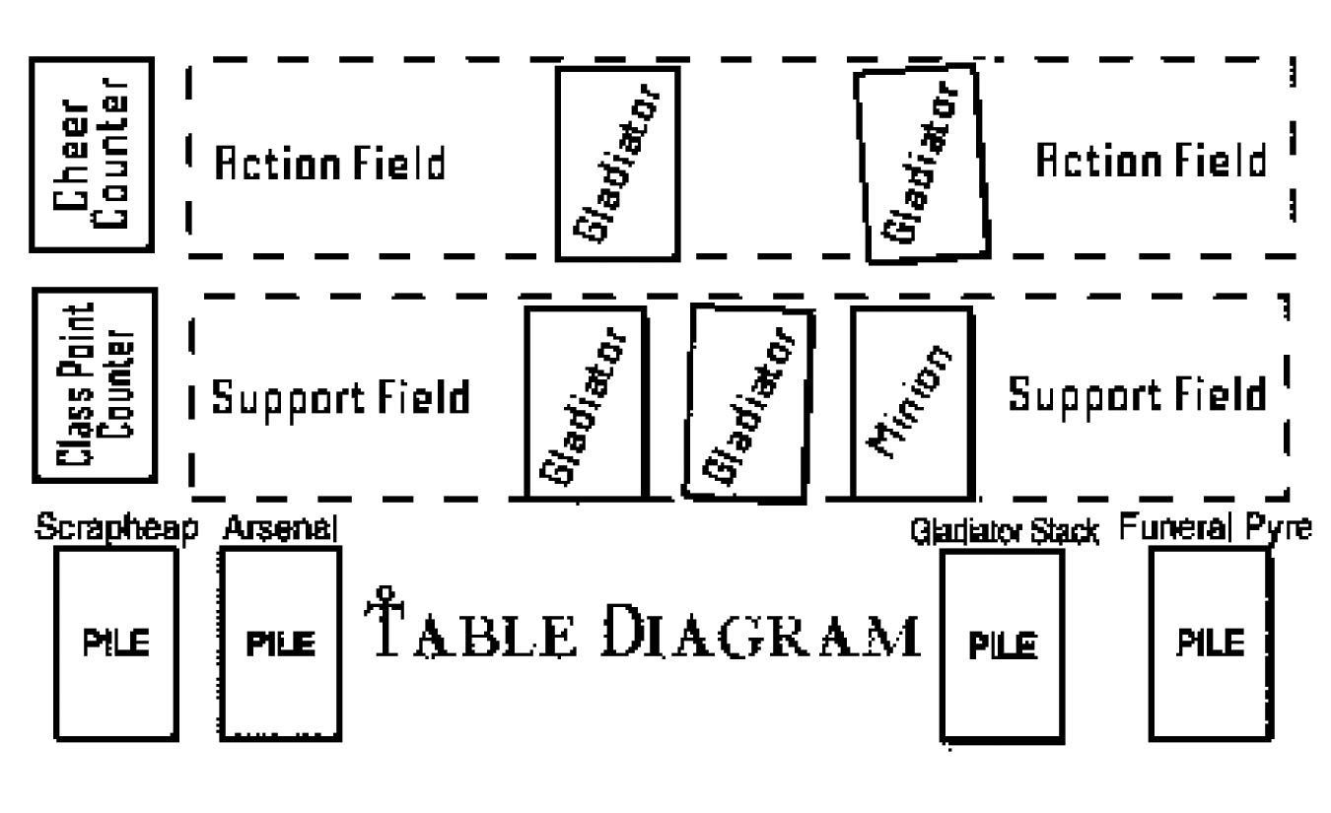
Figure 3: Table Layout

There are four stacks of cards in the game. These stacks still exist even if there are no cards in any given stack. The four stacks are the Gladiator Stack, the Funeral Pyre, the Arsenal, and the Scrapheap. (See Figure 3)

Gladiator Stack: This is where you keep your Gladiator cards before they are brought into play either at the start of the game or upon Promotion during the Breather. You are allowed to keep all higher Levels of your starting Gladiators and one Reinforcement Gladiator in your Gladiator stack.

Funeral Pyre: Destroyed Gladiators are placed face-up in your Funeral Pyre. Cards in your Funeral Pyre usually don't return to the game. Your opponent's Victory Point (VP) total is equal to the total VP of the Gladiators in your Funeral Pyre.

Arsenal: This is your face-down deck of available cards. These cards represent your Gladiator’s experience and strategy. When you draw, you take cards one at a time from the top of your Arsenal. Your Arsenal must contain at least 50 Strategy Cards, but may contain more if you’d like. Only 3 copies of a particular card may be included in your Arsenal.
Note: When you run out of cards in your Arsenal must play with only your remaining hand of cards.

Scrapheap: Cards that are Scrapped (discarded) are placed face-up on top of your Scrapheap. Scrapped cards usually don't return to a game.

There are also two special Fields into which cards are played: The Action Field and the Support Field. Zone cards do not occupy any specific Field position within the arena.

Action Field: The Action Field represents the center of the Arena, where all of the action is happening. A character cannot Attack unless it is in this Field.

Support Field: The Support Field represents the back edge of the Arena. Minions enter the game in the Support Field of the Arena. This provides added protection from Attack.

2.4 Ophidian Credit Points (CP)
The number of Credit Points () a Gladiator team has affects the number and strength of the Strategy Cards they can play and maintain. In each Wave, a player starts with 10 CP plus 1 CP for each Wave of play. For example, on the 1st Wave players start with 11 CP: 10 CP base + 1 for the 1st Wave. On the 3rd Wave players start with 13 CP: 10 CP base + 3 on the 3rd Wave.
Tracking CP: You can use the Counter Card to easily track CP. Just place a counter on the number you want to track. For numbers above ten use two counters, one for the tens place (10, 20, 30) and one for the ones place (1,2,3, etc).

2.5 Using the Flow
The Three Types of Flow-Related Actions-
The actions you make determine who is in control at any given moment. Actions can only be played one at a time. The three actions are (+), (-), and (?):

(+) Positive-Flow Action: You must have the Flow to use a Positive-Flow Action. Positive-Flow Actions require so little focus, that they do not cause you to lose Flow. If you make this type of Action, you will still keep the Flow, even if the Positive-Flow Action is unsuccessful.

Positive-Flow Actions include:
• Playing a card with the (+) symbol
• Using an ability with the (+) symbol
• Advancing
• Attacking

(-) Negative-Flow Action: You must have the Flow to use a Negative-Flow Action. Negative-Flow Actions require so much focus that they divert your Gladiator’s attention away from your opponent’s Gladiators, allowing your opponent’s Gladiators to steal the Flow. You lose the Flow after making a Negative-Flow action. When you lose Flow, the player to your left gains the Flow.

Negative-Flow Actions include:
• Playing a card with the (-) symbol
• Using an ability with the (-) symbol
• Retreating

(?) Undetermined-Flow Action: You must have the Flow to use an Undetermined-Flow Action. You could either keep the Flow (+) or lose the Flow (-) after making this action depending on its outcome. Undetermined-Flow Actions always contain some form of uncertainty.
The bottom game text on an Undetermined card will always resolve the Flow for that card. Undetermined Abilities will resolve within the text of the ability. If you do not fulfill the listed requirements, the opposite Flow results.
Example: "If you pay 1 CP: (+)". In this case, if you pay the 1 CP the action is (+), otherwise, it's (-).

Undetermined-Flow Actions include:
• Playing a Card with the (?) symbol
• Using an ability with the (?) symbol

The following types can be triggered even during an Action. They are Responses and Continuous effects:

(R/OR/DR) Responses: Responses do not cause a change in the Flow. You may choose to use a Response when the necessary requirements are met. Responses come in three varieties:
• Offensive Responses (OR) are played if you have the Flow
• Defensive Responses (DR) are played if you do not have the Flow
• Responses (R) can be played at any time, when appropriate

Responses include:
• Playing a card with the (R/OR/DR) symbol
• Using an ability with the (R/OR/DR) symbol

Continuous: If an effect does not have any symbol, it is a continuous effect that is either active at all times regardless of Flow or a mandatory effect whose timing will be determined by the text of that card. Unlike responses, you have no control over the use of these effects.
Note: Timing rules can be found in section 8.0

2.6 Passing
When a player is out of important actions and is ready for the next Wave, or for purely strategic reasons, they may Pass. Some abilities may also count as passes (PASS). When a player passes, he gives the Flow to the player on his left. If you pass, and the Flow returns to you, you may still make non-Passing actions.
When all players have passed in a row the current Wave ends and the players go to the Breather.
Note: Passing does not count as a (-), the player to the left of the Passing player simply gains the Flow.

3.0 Starting the Fight!
The game of Ophidian is broken into Waves. Each Wave is separated by a Breather. Your game will go like this:

• Setup
• Wave One
• Breather
• Wave Two
• Breather
• Wave Three
• Breather
• Wave Four
• Check for Victory

3.1 Setup
Pick your Starting Lineup: At the start of each game, players will design a Team of up to 4 Gladiators with a combined total of 10 Victory Points. All Gladiators you choose must be Level 1 Gladiators. You cannot play more than one copy of the same Gladiator on your team, but other players may choose the same Gladiator for their team.

Shuffle: Both players shuffle their Arsenals and cut their opponent’s Arsenals. Place your Arsenal face-down to your left (see Figure 3).

Draw: Both players draw up to their maximum hand size (which starts at seven), plus an additional two Bonus cards from their Arsenal and then place a number of cards at the bottom of their Arsenal equal to the Bonus cards drawn.

Set Starting CP: The First Wave players start with 11 CP (10 + 1 for the 1st Wave).

Decide Flow: Players roll a d6 (six-sided die) to determine who starts with the Flow. In the event of a tie, simply roll again.

Maneuver: Starting with the player with the Flow and continuing to the left, each player places their Gladiators in their starting Field positions. Each Gladiator can either start in the Support or Action Field.

Once Setup is complete, the first Wave begins.

3.2 Begin Play (Fight!)
The player with Flow kicks it all off by taking an action. If they can retain the Flow after that action, they make another. This continues until they lose the Flow. When a player loses the Flow, the player to their left takes over and will take their actions until they lose the Flow.

If you have the Flow you may do the following:
• Play a Strategy Card (+, -, or ?)
• Use an ability on a card in play (+, -, or ?)
• Advance (+)
• Retreat (-)
• Attack (+)
• Use Responses (R/OR)
• Pass

While you do not have the Flow you may:
• Use Responses (R/DR)

3.3 Playing a Card
Except for your Gladiator cards, most cards that enter the arena will come from your Hand, which is drawn from your Arsenal. In order for a card to enter the arena it must be played. To play a card successfully, you must meet certain requirements. Different cards will have different requirements, however all share the following main requirements:

1) Flow Requirement: To play most cards, you must have the Flow. Play Flow symbols appear in the upper-left corner of the card.

2) Discipline and Level Requirement: In order to play a card, a Gladiator on your team must have access to the Discipline of the card and the correct Level of that Discipline.
Example: Abe's Gladiators have access to the War, Cybernetics and Portal Disciplines. He may not play cards from the Bio-tek, Mystic or Psi Disciplines.
Example: A 2nd-Level Prince of Gates lets you play Portal cards rated at Level 1 or 2. A 1st-Level Prince of Gates could only let you play Portal cards rated at Level 1.
Some cards may even require you to have more than one Gladiator with the same discipline. If you need more than one Gladiator, you will see a smaller discipline symbol for each additional Gladiator needed who has access to that discipline. There is no Level requirement for the additional Gladiator(s).

3) Cost Requirements: To play a card, you must usually spend Credit Points (CP). To do this, subtract the CP requirement listed with the Cards Play Cost from your current CP pool.
Example: A Strategy Card requires 3 CP to play. A Gladiator team with 11 CP will spend 3 CP, leaving 8 CP leftover (11-3 = 8).

4) Other Requirements: Some cards have an additional Play Cost, i.e. discarding cards, scrapping a Minion. These costs MUST be paid for the card to be played. Any required Play Costs that are additional will follow a P symbol.

Once you have confirmed that you may play a card and paid all of the costs, the card enters play. When a card enters play, any immediate effects of the card are resolved and the card is then placed according to its type. For instance, Quick-Hits are Scrapped after they enter play. Last, Flow is determined.
Once a card is in the arena, only the requirements listed with its ability need be paid to use that ability.

Costs and Effects: Any text on the left of a colon is a cost and must be completely satisfied in order to activate the text on the right of the colon. Costs such as CP and Life can only be paid from your own resources.
Text on the right of a colon is an effect and must be followed; however, there are a few exceptions. If an effect tells you to do something that cannot be done, like drawing three cards when you only have two in your Arsenal, you need only draw the two you have. You can choose to ignore an effect if it gives a choice by using words like "may". If an effect allows you to pick between options with words like "or" and "unless" you choose only one.

Variables: Sometimes there is a variable value on a card, represented by X. X will often be defined in the text of the card in brackets. [like this]

Exceptions: Sometimes cards don’t always work like the rest of their kind… if something is an exception to the rules, or just works a little differently, this will be spelled out in parenthesis. (like this).
Note: Anything in parentheses that is dealing with a value will replace the previous value if it applies. You do not add them together.

3.4 Setting Cards
When a card is required to Set (), rotate that card 90 degrees. This is referred to as Setting the card. Rotating the card shows the other players that the Card can no longer do Setting actions until the card is re-energized in some way (usually during the Breather). To Unset a card, rotate it 90 degrees back to its original position. A card that is not Set is said to be Unset.

What causes a card to Set?
There a three main ways a card may become Set. First, if you use an ability on a card that has Set listed as part of its cost, you must Set the card to use that ability. Second, if you choose to use a standard game action that requires a card to Set, such as Attacking or Intercepting, you must Set the card to use that standard game action. Last, certain card effects might cause cards to Set.
Note: A Set Gladiator can still help you play cards. Using an ability on a card only causes it to Set if the ability has () listed as a cost of that ability. If a Pump requires you to Set it, that does not mean to Set the character it is Pumping, only the card itself. Also, any abilities on a card that don’t have a Setting cost can be used even when the card is Set.

3.5 Movement
Being in the wrong place at the wrong time can be deadly. If you want your team to survive, they must know how to Advance and Retreat.

Advancing: When you Advance a Character you are moving them from the Support Field to the Action Field.
Standard Advance: As a (+) action available to you whenever you have Flow, you may Advance an Unset Character you control. It would be written as follows:
(+): Advance an Unset Character you control.
Note: Card abilities that Advance characters do not have the limitations of the standard Advance.

Retreating: When you Retreat a Character you are moving them from the Action Field to the Support Field.
Standard Retreat: As a (-) action available to you whenever you have Flow you may move a non-Raging Character you control Back and you must Set that character if Unset. It would be written as follows:
(-): Retreat a non-Raging Character you control and Set that Character if Unset.
Note: Card abilities that Retreat characters do not have the limitations of the standard Retreat, and will not Set the Gladiator if Unset.

Movement Example: Maximillion is Unset in the Action Field. If he uses the standard Retreat he will Set and you lose Flow. Instead you use his card ability which says:
"(+) Pay 1 CP: Retreat Maximillion", and he Retreats as a (+) without Setting.

3.6 Attacks
Any Character with an ADMG value is capable of using a Standard Attack. The Attacking Character must be in the Action Field to declare an Attack. Attacks resolve as shown below.

Attack Declaration: Declare your Attack by naming the Attacking Character and the intended target. You can target characters in either the Support or Action Field. Only characters with a life value can be targeted by an Attack. You cannot target characters you control.
Once the Attacker has chosen his target, the Defender has the option to Intercept the Attack, Protect the Attack, or allow the Attack to hit its original target. If a character Intercepts or Protects the Attack, they become the new Defender for the Attack.
Note: After declarations have been made Cheer may be awarded (see rules on Cheer).

Attack (Attack Damage): The Attacking player now Sets the Attacker and deals Attack damage (ADMG) to the Defender. The Defender takes a number of Wounds equal to the ADMG value.

Defend (Defense and Rage Damage): Some abilities allow the Defender to deal Defense Damage (DDMG) back to the Attacker. If a Gladiator is Raging they may be able to deal Rage Damage (RDMG) as well (see Rage).
The Defender cannot deal Defense or Rage Damage if they Intercepted or Protected the Attack.

Attack Example: Abe uses Lothar to Attack Prince of Gates in the Support Field. Bill allows the Attack to hit. Abe Sets Lothar (2 ADMG) and an Arm Blade on Lothar (+2 ADMG). He deals 4 Attack Damage (ADMG) to Prince of Gates. Prince of Gates cannot deal Defense or Rage Damage so the Attack ends.

3.7 Intercepting and Protecting Attacks
Intercepting: If the Defender has an Unset Gladiator in the same Field as the Character targeted by the Attack, the Unset Gladiator can throw themselves in front of the Attack. This is called Intercepting. When the Defender Intercepts, they become SET and take the ADMG from the Attacker instead of the original target.

Protecting: Any Unset Gladiator in the Action Field may take the Damage for an Attacked character Targeted in the Support Field. This is called Protecting and does not cause the Protecting Gladiator to Set.

Intercepting and Protecting Example: Simon Bantus Attacks Little Jinx in the Support Field. Lothar is Unset in the Action Field and Goth Garal is Unset in the Support Field. Lothar can Protect and remain Unset or Goth Garal can Intercept by Setting.

3.8 Using XDMG
XDMG: This damage is dealt to a target and does not trigger any effects generated by being Attacked. You cannot Protect or Intercept XDMG.

3.9 Wounds and Destroyed Characters
When a Character sustains Damage, place a number of Wounds on him equal to the Damage value he has received. When a Character has a number of Wounds equal to or greater than his Life, he is Destroyed.
When a card is Destroyed or Scrapped, all Pump cards attached to them are Scrapped. Destroyed and Scrapped Strategy cards are placed in the Scrapheap. Destroyed Gladiators are placed in the Funeral Pyre.
Any Wounds and other effects are removed when a card is Destroyed or Scrapped.
If the Destroyed character is a Gladiator, the opposing player adds the Gladiator's Victory Points towards their Victory Points score. See Victory Conditions section 4.2..
Tracking Wounds: To track Wounds, place a die with its face-up number the same as the amount of Wounds on that Gladiator. You can also use counters to represent Wounds.

Healing: When a Character is Healed, remove a number of Wounds from him equal to the Healing value he has received.

3.10 Raging
This is the point at which Gladiators become enraged. When your Gladiator has at least as many Wounds as their Rage Value () they are Raging. There are three things to know about Raging Gladiators.
- If you Attack them while they are Unset: the Attacker takes 1 Rage Damage. This Damage will not prevent the attack if it is enough to defeat the Attacker.
- If you Attack them while they are Set: they Unset! Note: 1 and 2 cannot be used when intercepting or protecting.
- You cannot Retreat a raging character with the standard Retreat.
In addition, some Gladiator abilities do not work once the Gladiator is Raging represented by (), while some others only work when they are Raging represented by a .
Note: A Gladiator cannot use raging effects during the action in which they became raging.

3.11 How to Gain Crowd Favor
During a match, the crowd plays an important part – cheering and jeering combatants. If the crowd is in your favor they will help distract your opponent, raise your morale when you're down and possibly even win you the match.
The player with the most cheer is called the crowd favorite.
On the cards, crowd favorite is represented as () and if you don’t have the crowd favor it is ().
There are certain actions that the crowd looks favorably upon and which will gain you cheer counters.
These actions are:
When a Gladiator you control Attacks an Unset Character, a Cheer will be generated. If your opponent Intercepts the Attack, they gain the 1 Cheer Counter. Otherwise, you will gain the Cheer. If the target of the Attack becomes Set after the Attack is declared, the Cheer will still be generated as normal.

Cheer Can be Used in the Following Ways:
Being the () crowd favorite will allow you to gain extra benefits from some cards, and others allow you to use cheer to generate effects.
After a (+) action resolves, but before the next action is performed, you may trade in one cheer counter to change that action to a (-) action.
Note: You can trade in cheer after receiving cheer from intercepting during an Attack.
Tracking Cheer: Use the Counter Card to easily track Cheer. Just place a counter on the number you want to track. For numbers above ten use two counters, one for the tens place (10, 20, 30) and one for the ones place (1, 2, 3, etc).

3.12 Reinforcements: In the carnage that unfolds in the Ophidian Arenas, Gladiators will be lost. The Ophidian rules allow a team to contain one reinforcement card to replace a fallen Gladiator. Reinforcements are kept in your Gladiator stack and are identified by four main traits. All reinforcements are Level 0, have the Reinforcement keyword, have a standard Ophidian logo on the backside of the card, and are frequently the butt of many jokes.
Reinforcement Gladiators are still Gladiators and as such, are capable of all of the same actions as standard Gladiators.
Reinforcement Gladiators have a Maintenance Cost that MUST be paid. Reinforcements are brought into play during Promotion in the Breather.

4.0 The Breather
In the Ophidian Arenas, after all players have passed in a row during a Wave, the Breather begins. It ends when both players have completed the 5 steps in the Breather.

1) Determine Flow: The player to start the next Wave with the Flow is now chosen. The player with the most Wounds on their Gladiators' starts with the Flow (Destroyed Gladiators' life totals also count towards the Wound total).
If there is a tie, the Crowd Favorite starts with the Flow. If the crowd is undecided (cheer is tied), roll a d6.

2) Regenerate: Between Waves teams have only moments to recover.
First, All players Unset all Set cards they control.
Next, all players redraw. When players redraw, they may Scrap as many cards as they wish and then draw back up to their maximum hand size (maximum hand size starts at seven cards) plus two Bonus cards. Players finish re-drawing by placing a number of cards at the bottom of their Arsenal so that their hand size becomes equal to their maximum hand size.
Last, all players calculate the total CP for the current Wave and then reset their CP Pools to that number.

3) Maintain: Starting with the player with the Flow and continuing to the left, players figure out the cards that they wish to keep in play and pay their Maintain Cost. Any cards players don't wish to maintain are Scrapped. To Maintain Strategy Cards in the Arena, a player must deduct the maintain CP cost for the card from their CP Pool. Cards that have a skull symbol () in their Maintain area cannot be maintained. Face-down cards, including Zones, do not need to pay any maintain to remain in the arena. Maintenance Costs that MUST be paid, and are paid before any other Maintenance Costs.
Note: If you have too many Maintenance Costs that must be paid, your opponent can select which cards you have to Scrap until you are able to pay the cost for your remaining cards.

4) Promote: Starting with the player with the Flow and continuing to the left, each player may promote one Gladiator up one Level. To promote a Gladiator you must have the higher Level for that Gladiator available. The Level may be on the back of the Gladiator card or on a separate card in your Gladiator Stack. When a Gladiator is promoted they Heal 1 Wound. You may also bring a Reinforcement Gladiator into play if you have lost one or more Gladiators. (as long as it does not bring your total Gladiators higher than the number of Gladiators you started the game with).

5) Maneuver: Starting with the player with the Flow and continuing to the left, each player places all their Characters into their starting Field positions. Each Character can be positioned in either Field. Maneuvering is not considered Advancing or Retreating.

4.1 Continue the Match
After players complete the Breather, they go on to the next Wave.

4.2 Victory Conditions
You can play Standard rules or Death Match rules. If you play Standard rules, use all the three victory types listed below. If you play Death Match rules, only use the Annihilation and Crowd Riot victory conditions. Reinforcement Gladiators are not used in this format.

Annihilation Victory: If any player successfully eliminates all Enemy Gladiators, they win the game immediately.

Point Victory: At the end of the fourth Wave, both players add up all the victory points (VP) they have scored. The player with the most VP wins the game. If there is a tie after the fourth Wave, an elimination Wave is played. Elimination Waves are played until a victor is declared.
If a player ever reaches 12 VP, they win the game immediately.
A player scores VP in the following way:
For each enemy Gladiator a player has slain, they score an amount of VP equal to the VP value of the slain Gladiator.

Crowd Riot Victory: If any player is able to reach a cheer Level of 15, they win the game immediately.

5.0 Example Game
The Following example will take you through an entire Wave of gameplay from Setup to Combat and ending with the Breather. Our two players will be Abe and Betty.
Before the game begins Abe and Betty both prepared a 50 card Arsenal and a Gladiator Stack including their main Gladiators, the main Gladiator's extra Level cards, and their one allowed reinforcement. They have also brought dice, counters and counter cards to track Wounds, CP and Cheer. Both players reveal their 10-point Gladiator teams:
Abe: I have chosen David Dangers, Madame Petice, Little Jinx, and Poc Shot.
Betty: I also have David but will use his nickname: Freakshow. My other Gladiators are Version 9, Trace, and Stallion.
Abe and Betty each shuffle their deck and allow their opponent to cut them.
Then, Abe and Betty draw nine cards and place two on the bottom of the deck.
To play along, Abe, will be using Dripping Leak, Festering Stink, Let Freedom Ring, Bloaters and Drosh.
Betty will be using Phase Blades, Mega-ram Boost, Arachnabots, and Distraction.
Abe: Let's see who starts with Flow. I rolled a six.
Betty: I rolled a four. You have Flow.
Abe: Since I have Flow I must maneuver first.
Abe places David Dangers and Madame Petice in the Action Field and Little Jinx and Poc Shot in the Support Field.
Betty then places Freakshow in the Action Field and Version 9, Trace and Stallion in the Support Field.
Abe: Ok, as my first action I will play (+) Dripping Leak on Version 9. I have a Level 1 Bio-tek Gladiator and an extra Bio-tek Gladiator as the card requires. It costs 2 CP to play leaving me with 9 CP. Since it is a (+) action to play I keep Flow.
Betty: Savor the moment, because it won't last long.
Abe: Big talk, but try saying the same after this. I play (-)Bloaters, which costs 3 CP leaving me with 6.
Abe places Bloaters in the Support Field where all Minions enter play.
Betty: That was a (-) to play so I gain the Flow. I play (-) Phase Blades on Version 9. It costs 2 CP leaving Betty with 9 CP.
Abe: I play (-)Let Freedom Ring and destroy your Phase Blades for its play cost of 2 CP, leaving me 4 CP.
Betty: His Phase Blades may be gone, but Version 9 is still ready to reach out and maim someone. I now Set Version 9 to use his (-) Grappling Strike ability on Poc Shot.
Abe: After Version 9 Sets, dripping leak causes you to take 1 Damage or Scrap three cards from the top of your Arsenal.
Betty: Betty scraps three cards. Grappling strike Advances Poc Shot and then deals 1 Damage to Poc Shot.
Abe Advances Poc Shot.
Abe: Poc Shot takes 1 Damage and is now raging! Poc Shot receives one Wound. I have Flow now and will Play (-) Festering Stink on Version 9 for 2 CP, leaving 2 CP.
Betty: I now play (+) Mega-Ram Boost for 1 CP and then (-) Arachnabots for 1 CP, leaving me 7 CP.
Abe: That was negative so I have Flow. I will Attack Version 9 with Madame Petice for 2 Damage! Abe Sets Madame Petice.
Betty: Sorry Abe, but I play (DR) Distraction for 3 CP, which lets me reduce the damage by 1, leaving only 1 Wound!
Abe: That worked once but it won't work again. I Attack Version 9 with David Dangers for 2 damage.
Abe Sets David Dangers.
Betty: You win this time. I could protect but Version 9 is tough. Version 9 takes 2 Damage making a total of three Wounds. Betty places a die face-up on the number three to show the three Wounds.
Abe: I'll play (-) Drosh for 2 CP. Abe has no CP left.
Betty: Poc Shot is alone and helpless. You cannot protect him. You also have no cheer because you Attacked Version 9 who was Set. I Attack Poc Shot with Freakshow for 2 Damage. Betty Sets Freakshow.
Abe: You think you have me but you don't. Betty gains 1 Cheer. Poc Shot Takes 2 Damage and now has 3 Life remaining and Freakshow takes 1 Rage Damage.
Betty: I'm the crowd favorite now and I don't think you can save Poc Shot. I Advance Trace, then Stallion. Now I Attack Poc Shot with Trace. Betty Sets Trace.
Abe: He takes it. Poc Shot has 2 life left and Trace takes 1 damage from Poc Shot's Rage.
Betty: I gain another cheer. Here comes Stallion for 1 at Poc Shot. I use (OR) One-two Punch. Betty rolls a 4 and fails. No damage added so it's still 1 Attack damage to Poc Shot. Betty Sets Stallion.
Abe: He will take it.
Betty: I gain another cheer and now have three. The crowd is mine!
Abe: Poc Shot has 1 life left and Stallion takes 1 damage from Poc Shot's Rage. You still have Flow. Abe crosses his fingers.
Betty: Sorry but Poc Shot must go down! Arachnabots for 3 CP deals one damage to both Poc Shot and David Dangers. Betty Sets Arachnabots and has 1 CP remaining.
Abe: Poc Shot is Destroyed. You will pay for that before the match ends!
Betty: I doubt that. You have Flow.
Abe: I Advance Little Jinx and then Attack Version 9 with Little Jinx for 1 Damage. Abe Sets Little Jinx. Betty places a fourth Wound on Version 9. Now I Advance and then Attack Version 9 with Bloaters. Abe Sets Bloaters and Betty places a fifth Wound on Version 9. I'm not through yet. Drosh will now do his part. Drosh Advances and then Attacks the exhausted Version 9 for 1 more! You may have taken Poc Shot but when Version 9 finally goes down I will be in the lead. Abe Sets Drosh.
Betty: He takes it and now has six Wounds. Your threats can't frighten Version 9!
Abe: I pass.
Betty: I pass also. Now the breather begins.
Abe: I received 7 Wounds including 6 on Poc Shot who is Destroyed and you took 9 Wounds so you start with Flow.
Abe and Betty Unset, draw (Betty gets an additional card due to Mega-Ram Boost), and Set their CP pool to 12 for the second Wave.
Betty: I will maintain Arachnabots and Mega-Ram Boost leaving 10 CP.
Abe: I will maintain Dripping Leak, Bloaters and Drosh leaving me with 9 CP and I will not maintain Festering Stink.
Betty: I will Promote Version 9 to second Level, healing 1 Wound.
Abe: I will promote David Dangers to second Level, healing 1 Wound and place a reinforcement into play to replace Poc Shot.
Betty places Freakshow and Version 9 in the Action Field and Trace and Stallion in the Support Field.
Abe then places David Dangers and Madame Petice in the Action Field and Little Jinx and a Reinforcement in the Support Field.
Abe: Ok, time for my revenge!

6.0 Ophidian Disciplines and Species
In the vastness of space, there is a seemingly infinite array of abilities and species. In truth, though, scientists have been able to classify most into the following categories:

Disciplines:
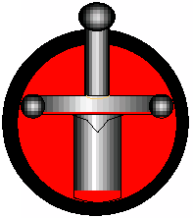 War: Gladiators who make use of the War Discipline are skilled in the art of fighting, weaponry, armor and battle-tactics. In the arenas, a well-trained warrior can provide leadership and knowledge that others may lack.

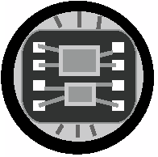 Cybernetics: This Discipline represents those Gladiators who specialize in high technology and the use of resources including robotics and cybernetics. With ever-increasing technology, comes ever-increasing devastation.

 Portal: With this Discipline, a Gladiator can manipulate dimensions, time, and space. Portals are gateways, which can lead to infinite possibilities. What horrors may lurk in other dimensions, and what will they do when unleashed?

 Bio-tek: The Gladiator's association with genetics and radiation makes disease and mutation kin to their abilities. With disease, the Gladiator can make their opponent sick and weak. With mutation, the Gladiator can change a character, molding him to any purpose or design.

 Psi: Some Gladiators have telepathic abilities. A Psi Gladiator can enter an opponent's mind to reveal hidden information or change their thoughts. Psi Gladiators are the kings of manipulation, but their power can become physical as well. The dagger of the mind may be the strongest of all.

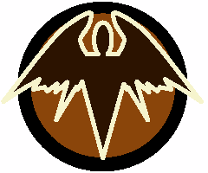 Mystic: Using ancient techniques, mystics can heal wounds, prevent damage, and harness powers beyond the bounds of science including ghosts and spirits. What shines within the brightest light and lurks within the darkest shadows? Only mystics may know the hidden truths.

 Universal: Cheerleaders, the crowd, the media... these are available to anyone, as almost no one is immune to a little bribe here and there. Cards with the Universal symbol can be used in any Arsenal, regardless of the symbols available on your team. Any discipline will satisfy this card's requirement.

Species:
Alien: These species represent a vast array of life forms across the known galaxies that can be catalogued according to structures similar to DNA.

Construct: Any being created by design and not born through any natural or organic means may be labeled a Construct, although the lines may many times be blurred.

Demon: Beings of an extra-dimensional origin representing a wide variety of racial types. Their early intrusions into other dimensions have left a large impact on the mythos of many different worlds.

Human: A race of beings known throughout the universe and a staple of the Ophidian Arenas. Their simple DNA and prevalence within the Ophidian sphere have made them a base from which alien life forms are measured.

Spectral: These beings are of unknown origin and design, representing differing forms and Levels of energy. Many Spectrals assume solid states when in contact with other races and they are believed to have many hidden powers.

7.0 Multi-Player
Multi-player is extremely easy and fun to play. The rules go as follows:
- Negative (-) actions go to the player on the left. (Just like regular play)
- You can only affect and be affected by the player to your immediate left or right.
- Keep Gladiators in your funeral pyre separate so you know which player Destroyed which Gladiator and has earned the VP.
- If a Gladiator dies due to your own actions, the card goes into a pool. The first other player to Destroy another Gladiator you control counts as if they Destroyed the Gladiators in your pool. If you are eliminated from the game and Gladiators are still in your pool, the next player to your left or right that Destroys a Gladiator counts as if they Destroyed the Gladiators in your pool.

8.0 Advanced Rules:
If you find yourself needing more detail on certain mechanics you can find them here.

Timing: To determine the order of timing, first all Continuous effects resolve, then all Responses.
For Continuous effects, the player with the Flow has their effects resolve, then in clockwise order from that player, each player has their effects resolve. For Responses, the player with the Flow may play a Response (R and OR) for that action. Then in clockwise order from that player, each player may play a Response (R and DR) for the action. The player with the Flow can then play another Response and so on.
Continuous effects and Responses are resolved one after the other on a first-in first-out basis.
Example: Player with Flow plays offensive response (OR) that adds one Damage to the Attack. Player on defense then plays a defensive response (DR) that lowers the Attack to zero Damage. First the Attack was raised by one Damage, then the Attack was lowered to zero Damage making the final Attack zero Damage.
Responses must be played before a new game action takes place. Once a Response has been played you are in an event chain and can play Responses to any event that occurred in the chain.
Example: A player is Wounded and you play a (R) that gives you CP after a player is Wounded. Now you and your opponent can play Responses to the Wounds and the CP gain and so on.
Note: A Response or Continuous effect can only be used one time per card in an event chain. Multiple copies of the card or the same ability on different cards are allowable.

Responses come in two main forms: Event and Modifier.
All Events start with "After…" and add a new event to the event chain that you and you opponent can also react to with event Responses and modify with modifier Responses.
All Responses that start with "When" add effects to an event already in play. A modifier Response can not be modified itself, only the event it is modifying. Modifier Responses must be played directly after the event it’s modifying is played and before it resolves. Your opponent must have opportunity to play modifier Responses before moving to the next event.
Example: A player is trying to play a card. The player with Flow now plays a modifier (R) that says, "When a card's cost is being paid, raise the cost by 1 CP."
The opponent also has this card but cannot play it against the modifier's cost because modifiers cannot be modified directly. Instead they play a card that says, "When a card is modified, remove any modifiers from that card". With no more Responses to play the event chain ends and the card is played at normal cost and it Damages the opponent for 1 Wound. The player with Flow now plays an event modifier that says, "After a character is Wounded, gain 1 CP". No more responses are played so the game progresses to the next action. At this point no more responses to the Wounding or CP gain can be played.

Temporary Flow: The last player to pass is counted as the player with Flow until a new player with Flow is chosen in the Breather.
Example: Two players have "After a Wave ends" responses. Using normal timing rules, the last player to pass has Flow and resolves one of his responses, then the other player and so on.

Examining cards: All players can examine face-up cards including cards in their opponents Scrapheap and Funeral Pyre. Players cannot examine any face-down cards, including face-down Zones.

Revealing Cards: If an effect allows you to take a specific type of card from a pile such as the arsenal or if a card uses the word reveal, the card must be shown to all players before being placed according to the text of the card. You do not need to reveal cards when you Draw them.
Example: A card effect says: "Take a War card from your arsenal into hand". You must reveal it before placing it into your hand.
Example: A card effect says: "Reveal a Mystic card from hand to heal 1 Wound from target character". You must reveal it before placing it back into your hand.

In Play: Cards that are in the Arena (not in the Scrapheap or the Funeral Pyre) are considered in play. Cards in your hand are not considered in play. Unless an effect mentions the hand, Arsenal, or any other specific card area, it will only effect cards In Play.
Example: A card effect says: "All Zones are Scrapped." Only Zones in the Arena will be Scrapped. Zones in your hand, scrapheap, arsenal etc. are not affected.

Keywords: Cards may refer to keywords. Keywords are always listed in this font. A keyword can be used in plural and possessive forms and still refer to the same keyword. Keywords are separated by a (۰) and may be more than one word long. If a keyword is more than one word long or made up of more than one word, the keyword can only be referenced by its full text.
The name of a card can be used as a Special Keyword and can only be referenced by its full text. It is a Special Keyword because when a card's name appears in its text, it refers only to itself, not to all cards with the same name. When a card refers to its own name in this way it is called a Reference. The exception is if the card uses language such as "any", "all", or "target" to refer to other cards with the same name.

Unique Keyword: Cards with the Unique keyword can only be in play one at a time for any one player. Quick-Hit cards with the Unique keyword can only be played once per wave, per player.

The X: An X may appear on a card either in its cost or as part of an ability. The X is a temporary placeholder for a number. Once the number for X is determined, that number replaces all X's on the card. Effects that refer to numbers, refer to X as 0 unless the X currently holds a value. The value of X is sometimes defined in brackets [like this].
Example: A Pump costs X to play and the player pays 3 making X equal to 3. After the card is played, the X no longer holds a value. Cards that Destroy all cards with a 3 CP or higher cost can no longer affect it because X is now 0.
Example: A character has an X ADMG value where X equals their remaining life. The character's remaining life is 3, so X is equal to 3. This is a constant effect. A card that Destroys all characters with a 3 ADMG value can affect it.

Paying Life (): You cannot pay costs that you do not have. This includes paying Life. When a cost requires a character to pay Life, they can only pay up to that character's remaining life. When you pay life, place a number of Wounds on that character equal to the life paid.
Example: A Gladiator has 1 life left and an ability that allows them to pay X life () to draw X cards. They may only pay 1 life, since that is the amount of life remaining on that Gladiator.

Flow within effects: If an effect has a Flow type and within that Flow type it allows you to make an action that would normally have its own Flow type, the Flow type of the first effect is used and all effects are considered part of a single action.
Example: Madame Petice has the ability "- Channeling: While unset: MADAME PETICE may use a - or ? ability of target Gladiator in your Funeral Pyre. Set her." When you use the Destroyed Gladiator's ability it is counted as part of her Channeling ability’s effect, which is a (-) action.

Effect Sources: Whenever a card produces an effect, the effect carries along with it all information about the source of that effect including the name, discipline type, keywords, and costs of the card from which it came.
Pumps that modify values transfer their information to the modified portion of the value only.
Example: A Bio card with the keyword Affliction deals 1 DMG to a character. Any cards that refers to Bio DMG or Affliction DMG can effect that DMG.
Example: Ironsides has Spiked Fists, a War weapon, which gives him +1 Attack DMG making his total 3 Attack DMG. If he were Attacking and an effect were used that reduced all weapon DMG by 2, only the +1 Attack DMG from Spiked Fists would be lost, since Ironsides' base Attack DMG is not considered from a weapon.

Duration of effects: Any effect that changes a tracked game value (CP, Wounds, cheer, etc) or that changes a game state (Setting, Field position, Scrapped, etc) is permanent.
Any effect that changes a temporary value or a value that doesn't get tracked only lasts within the space it was declared. Some cards may state the duration of the effect.
Example: A response says "Target character gains +1 Attack DMG". Since Attack DMG isn't tracked it must be used during an Attack for it to have an effect.

Destroy and scrap effects: If a card is Scrapped as part of the cost of an effect, the effect still takes place. Also, if a card has an ability that is triggered after the card is Destroyed, the effect still takes place.

Negative Values: Any effects that would cause a game value such as Life and CP to go into negative numbers becomes 0 instead after all effects for that action have been tallied and the number is resolved.
Example: An effect reduces ADMG number to -2 and another adds +3, and both were responses to a single action, the final number would be +1, not +3. If the ADMG had stayed -2, it would have become 0.

Modifying Values: An effect cannot modify a value on a card that does not have that value.
Example: Most Minions do not have a Rage value. If a card is played on a Minion with no Rage value that gives him +1 rage, that Minion still has no Rage value.

Targeting: Some effects require a target or multiple targets in order to function properly. The controller of the effect always chooses the target. If a card does not use the word target, than cards that refer to targets cannot affect them. Cards without targets will use "a" "one" or "all" to single out those referred to by the effect.
Pumps always target the Pumped character when they are played on them. Attacks must single out the target of the Attack.
When a target is redirected by an effect only a new valid target can be chosen. If no valid target remains, the effect fails, and all costs paid are lost. Any costs that were not paid at the time the target is lost do not need to be paid.
Example: Abe declares an Attack with Ironsides against Bob's Prince of Gates. Bob Pays 2 CP and uses Hidden Danger, which makes Abe choose a new target. Since Prince of Gates is Bob's only character and Abe cannot Attack his own characters, no valid target remains. Since Abe did not yet Set Ironsides; which happens after Attack declaration; he remains Unset and can Attack again.

Gaining and Using Other Card's Abilities: If a card gains an ability or uses an ability from another card, and the ability references its card by name, that name is replaced with the name of the card gaining/using the ability.

9.0 Glossary
Ability: A capability found in the text box on a card.
Action: (+), (-), or (?) are considered Actions.
Action Field: Field in the Arena that Attacks are made from.
ADMG (Attack Damage): Special Damage dealt from the Attacker to the Defender.
Advance: Move a character from the Support Field to the Action Field.
Annihilation Victory: Win by eliminating an opponent's entire Gladiator team.
Arena: The main playing Field in which the battle takes place.
Arsenal: Deck of strategy cards from which you draw your hand of cards.
Attacker: Character making an Attack.
Bonus cards: These are the extra cards you draw when refreshing your hand.
Breather: Allows players to prepare for the next Wave.
Character: Refers to all character types including both Gladiators and Minions.
Cheer: Representation of the crowds' favor and intensity Level.
Credit Points (): Resource used to play cards and use abilities.
Continuous Action: Effects that last while a card is in play and cannot be ignored.
Control: You control any card you bring into play. This includes Pumps placed on other players' cards. You may gain control of cards you do not own.
Crowd Riot Victory: Win by accumulating 15 cheer.
Damage: To inflict Wounds on a character.
DDMG (Defense Damage): Special damage dealt by the Defender to the Attacker.
Defender: The target of an Attack.
Destroyed: After the number of Wounds on a character is equal to or greater than their life, or an effect says so, a character is Destroyed.
Discipline: Specialization of a fighting style.
DMG: This is any kind of damage. It is a way of generically referring to damage of any type.
Draw: Take a card from the top of your arsenal to your hand.
Effect: End result of an ability. General word for something that causes a change in the game.
Flow: The main way through which the battle's action unfolds, determining which players may make actions and when. Deciding Flow is a step of the Breather.
- Negative-Flow (-) action: Lose the Flow after the action.
- Positive-Flow (+) action: Keep the Flow after the action.
- Undetermined-Flow (?) action: May keep or lose the Flow after the action.
Funeral Pyre: Pile in which your Gladiators are placed after they are Destroyed.
Gladiator: Main characters around which the game revolves.
Gladiator Stack: Pile in which your Gladiator cards are kept until they are brought into play.
Heal: Remove Wounds from a character
Intercept: Setting a Gladiator in the same Field as Defender and becoming the new Defender.
Keyword: Special words used to group and define cards.
Maintain: Keeping a card in play for another cycle. Step of the Breather.
Maneuver: Players reposition their team for the next Wave. Step of the Breather.
MAX Life (MAX ): The amount of wounds a character can take before they are Destroyed.
Minion: Type of strategy card that represents support characters.
Own: You own any card you bring to the game.
Pass: Give Flow to the player on your left.
Pay: A cost that must be paid in full to allow the use of or prevent an effect.
Point Victory: Win by accumulating 12 VP, or by having the most VP after 4 waves.
Promote: Bring a Gladiator to the next Level of experience. Step of the Breather.
Protect: Take damage while Unset from the Action Field for a character in the Support Field.
Pump: Strategy card type that attaches to other cards.
Quick-Hit: Strategy card type that has an immediate effect and is Scrapped after use.
RDMG (Rage Damage): Damage dealt by a Raging Gladiator when Attacked and Unset.
Raging: A Gladiator is Raging when their Wounds equal or exceed their Rage Value.
Reinforcements: Replacement Gladiators.
Regenerate: Players Unset, Redraw, and Refresh CP. Step of the Breather.
Response (R, OR, DR): Effects playable when triggered, even during an action.
Retreat: Move a character from the Action Field to the Support Field.
Reveal: To show to all players.
Scrap/Scrapped: A Scrapped card is placed in its owner’s Scrapheap (Discard Pile).
Scrapheap: Pile in which Scrapped and Destroyed strategy cards are placed.
Set (): Rotate a card to a horizontal position.
Shuffle: Mix a deck of cards to create a random draw.
Strategy Card: Main card type from which your arsenal is composed.
Support Field: Field in the arena that provides added protection from Attack.
Target: When using an effect that requires a target, the player using the effect must select the target of the effect i.e. If you play a card that says "Target Minion is Destroyed", you must select the Minion that will be Destroyed.
Unset: Rotate a card to a vertical position.
Victory Points (VP): Points used when building a Gladiator team and received when killing a Gladiator.
Wave: All major game action takes place during the Wave. A Breather separates Waves.
Wounds: The amount of Damage a character has taken.
XDMG (XDMG): This damage is dealt to a target and does not trigger any effects generated by being Attacked. You cannot Protect or Intercept.
You: Refers to you as the player directly. ‘You’ always refers to the card's controller.
Zone: Strategy card type affecting the arena and that can flip up and down.

Lead Designers: Shaun Mahar, Gregg Schwartz, Raffi Tasci

Designers: Kevin J. Coleman, Ed Lasso, Jason Robinette, Carl Van Ostrand

Design Consultant: Richard Weld

Beta Testers: Gregory Wilson, Michael Kirby, Chris Pottorf, Thomas Michaels, Jr., Toby Thelin, William A. Smith, Jon Darnaby, Andy Palmer, Dave Gunn, Chris Gunn, Beau Schmitz, Ken Howard, Robert Simpson, Zachary Johnson, Michael Jordal, Chris Ruder, Josh Windon, Marshall James, Jon Custer, Mike Grimberg, Dr. Rich Staats, Joe Gaskill, Ken Bryer, Bart Bressler, Stephen Barlow, Ned Burns, Josh Considine, Eric Healy, Andrew Taylor, Steven Suggs, Eric Boivin, David Boucher, Helen Gascon, Helge Blohmer, Agnes Ogbomon, Ryan Patterson, Rob Oakes, Greg Wood, Justin Collins, Mike Carr, Shannon Carr, Nathan Carr, David Evans, Ben Young, Jeff Hansen, Aaron Moore, Abner Wyatt, Chris Wodicka, Wayne Cullen, David Kangas, John Davis, and Steve Norton

Special Thanks: We would like to thank Fleer for producing/distributing Ophidian - Their commitment to producing a high-quality game has been second to none; David Stark for design Sketches. Max Moskowitz, David Linn, Peter McAliney, Jeff Calderon, Austin Mini Storage, & Raymond James O’Brien III. All of the CCG designers of the past and present for inspiring us to become CCG fans.

We would like to thank all of our families for being so patient and supportive: Norayr, Margrit, Ari (Vin D), Linda, Michael, Phyllis (Nan), Bri, Robert (The Brubbs), Sam (The Ripper), Leah, Jon, Lauren, & Lou

Steps of the Breather

Flow - Regenerate - Maintain - Promote - Maneuver

Flow Chart

Positive-Flow Actions (Need Flow - Keep Flow) include:
• Card/ability with the (+) symbol
• Advancing
• Attacking

Negative-Flow Actions (Need Flow - Lose Flow) include:
• Card/ability with the (-) symbol
• Retreating

Undetermined-Flow Actions (Need Flow - either + or - ) include:
• Card/ability with the (?) symbol

Reponses (No Change in Flow) include:
• Card/ability with the (R/OR/DR) symbol

Passing (Need Flow - Lose Flow)

